­Pann’s design brief GA

MOODBOARD

COLOUR SCHEME

The color scheme in the image is **Analogous**.

Analogous color schemes use colors that are adjacent to each other on the color wheel. In this case, the colors gradually shift from brown to green, creating a harmonious and visually pleasing progression.

COLOUR PALETTE

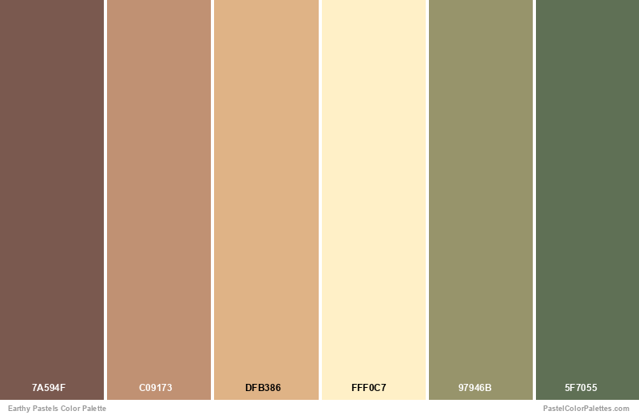

FONTS USED:

Minion Variable Concept 

Calder Dark Grit Shadow

Segoe UI Variable

LOGO DESIGN/RATIONALE

The design rationale for this name card is rooted in the desire to create a visually appealing and memorable card that reflects my personality. By combining a minimalist aesthetic, a panda illustration, and a clean layout, the design effectively communicates approachability, creativity, and professionalism. The asymmetrical eyes are intentionally designed that way; I shaped the left eye into a 'p' and the right eye into an 'a' to represent the first two letters of my name.A cartoon of a panda face

DESIGN RATIONALE FOR ALL 3 COMPONENTS

**Name Card Design**

The name card showcases a minimalist, playful design featuring a whimsical panda illustration, reflecting approachability and creativity. Sage green, beige, and dark sage green text provide sophistication. A simple sans-serif font ensures readability, with a subtle hierarchy highlighting the individual's name. The front of the card features the panda illustration, and the back contains contact information. This design appeals to a young, creative audience who values a minimalist and visually appealing aesthetic, effectively combining playfulness and professionalism.

**Design Principles:**

* **Balance:** Visual balance with the panda on one side and text on the other.
* **Contrast:** Muted background contrasts with the dark sage text; panda contrasts with formal typography.
* **Emphasis:** The panda illustration is the focal point.
* **Unity:** Consistent color palette and font usage.
* **White Space:** Enhances readability and cleanliness.

**Chat Stickers**

The chat stickers are charming and playful, using a soft color palette to create a friendly vibe. Stickers include a panda with fluff, panda with glasses saying "Hi," panda with pizza, boy with a burger, and a sad boy with a bun head. These stickers add personality to conversations, appealing to those who enjoy cute and relatable characters.

**Website Design**

The website is designed to showcase diverse artistic skills with a clean, minimalist aesthetic, emphasizing readability and user experience. It features a grid-based layout, simple sans-serif typography, and a sage green, forest green, beige, and gray palette. High-quality visuals display versatility, while social media integration extends audience reach. The design balances content symmetrically, uses contrast to enhance readability, and employs hierarchy to guide attention, creating a cohesive and visually appealing portfolio for art enthusiasts.